EOSC-Future TSP “META-COVID”: Final report for CESSDA – ECRIN use case

Authors: C. Ohmann, M. Panagiotopoulou (ECRIN), K. Moilanen, M. Kleemola (CESSDA)
Date: 29.9.2023
Version: Final

- Background
Within the EOSC-Future TSP “META-COVID”, a use case has been developed to bridge resources between ECRIN (MDR) and CESSDA (DC). Work started in the EU-funded project BY-COVID with the presentation “Bridging scientific domains with metadata: CESSDA and ECRIN” (https://zenodo.org/record/7406078). The foundation of the use case is described in detail in “ECRIN – CESSDA strategies for cross metadata mappings in selected areas between life sciences and social sciences and humanities“ (to be published in Open Research Europe). In this paper we investigated whether metadata schemas and vocabularies used for discovering scientific studies and resources in the social sciences and humanities and in clinical research are similar enough to allow information from different source disciplines to be easily retrieved and presented together. As a first step a literature search was performed, exemplarily identifying studies and resources, in which data from social sciences and the humanities have been usefully employed or integrated with that from clinical research and clinical trials. In a second step a comparison of metadata schemas and related resource catalogues in ECRIN and CESSDA) was performed based upon a metadata crosswalk (https://zenodo.org/record/8129621). A close view at the metadata schemas of CESSDA and ECRIN and the basic discovery metadata as well as the crosswalk have shown that there is considerable resemblance between them, serving as a promising starting point to implement a common search mechanism for ECRIN and CESSDA metadata.

- Demonstrator

For the implementation of the use case demonstrator, it was decided to provide a new, single search interface ‘over the top’ of both systems, with the results integrated to some extent, but with each returned study linking back to details in the source system. The demonstrator tool was developed by ECRIN:

Frontend:
Language: typescript v.4.1
Framework: Angular 12

Backend:
Language: python v. 3.11
Framework: FastAPI
Data storage: elasticsearch v. 8.9

The demonstrator can be accessed via the following link: http://51.210.99.18:4234/.
With the demonstrator it is possible to search in parallel in the ECRIN MDR and the CESSDA DC. Free text search in the “title” (different or identical for ECRIN and CESSDA), provides a list of the retrieved hits according to a priority scheme defined and implemented by CESSDA. The free text search may be further restricted by filtering according to pre-defined study types (e.g., interventional study, observational study, cohort, case-control study).

Initially, a mapping table for “study types” between CESSDA and ECRIN was provided, based upon the DDI Alliance Controlled Vocabulary for CESSDA and the standardised filter criteria from the ECRIN metadata schema.

Study type | CESSDA* | ECRIN MDR
Interventional | Mode of collection  “Field/Intervention experiment” | General studies filter  Type = “interventional
Randomised | Sampling procedure  “Non-probability: Purposive”  and a term describing the selected randomisation  “Probability”; “Probability: Simple random“; “Probability: Systematic random”; “Probability: Stratified”; “Probability: Stratified: Proportional”; “Probability: Stratified: Disproportional”; “Probability: Cluster”; “Probability: Cluster: Simple random”; “Probability: Cluster: Stratified random”; “Probability: Multistage” | Interventional studies filter  Allocation type = “randomised”
Observational | Mode of collection  “Observation”; “Field observation”; “Participant field observation”; “Non-participant field observation”; “Laboratory observation”; “Participant laboratory observation” or “Non-participant laboratory observation” | General studies filter  Type = “observational”  or  Type = “observational patient registry
Cohort study | Time method  “Longitudinal: Cohort/Event-based” | Observational studies filter  Observational model = “cohort”
Cross-section | Time method  “Cross-section” | Observational studies filter  Time perspective = “cross-sectional”
Case-series | missing | Observational studies filter  Observational model = “cases only”
Case-control | missing | Observational studies filter  Observational model = “case-control”
Randomised sample | Sampling procedure  “Probability”; “Probability: Simple random“; “Probability: Systematic random”; “Probability: Stratified”; “Probability: Stratified: Proportional”; “Probability: Stratified: Disproportional”; “Probability: Cluster”; “Probability: Cluster: Simple random”; “Probability: Cluster: Stratified random”; “Probability: Multistage” | missing
Simulation studies | Mode of collection  “Simulation” | missing

Table 1: Mapping of study types between CESSDA DDI and ECRIN MDR
*DDI Alliance Controlled Vocabulary
It turned out that a search based upon the controlled vocabulary of CESSDA did not provide satisfactory results, mainly due to the still limited application of the controlled vocabulary to CESSDA resources, resulting in a substantial number of missing studies, if the search is based on the controlled vocabulary. Therefore, it was decided to use the standardised ECRIN filter criteria on one hand and a free text search for CESSDA on the other hand:
Study type | CESSDA (free text) | ECRIN MDR
Interventional | “interventional” | General studies filter  Type = “interventional
- Randomised | “randomised” | Interventional studies filter  Allocation type = “randomised”
Observational | “observational” | General studies filter  Type = “observational”  or  Type = “observational patient registry
- Cohort study | “cohort” | Observational studies filter  Observational model = “cohort”
- Cross-section | “cross-section” | Observational studies filter  Time perspective = “cross-sectional”
- Case series | “cases only” | Observational studies filter  Observational model = “cases only”
- Case control | “case-control” | Observational studies filter  Observational model = “case-control”

Table 2: Mapping of study types between CESSDA based upon free text search and ECRIN MDR

Free text search in the title allows simultaneous searching in CESSDA DC and ECRIN MDR. A search for “COVID-19 vaccination” in the title (treated as a logical “and”) revealed 471 hits in ECRIN MDR and 68 hits in CESSDA DC (search from 28 September 2023). This is illustrated by a screen shot (Figure 1).

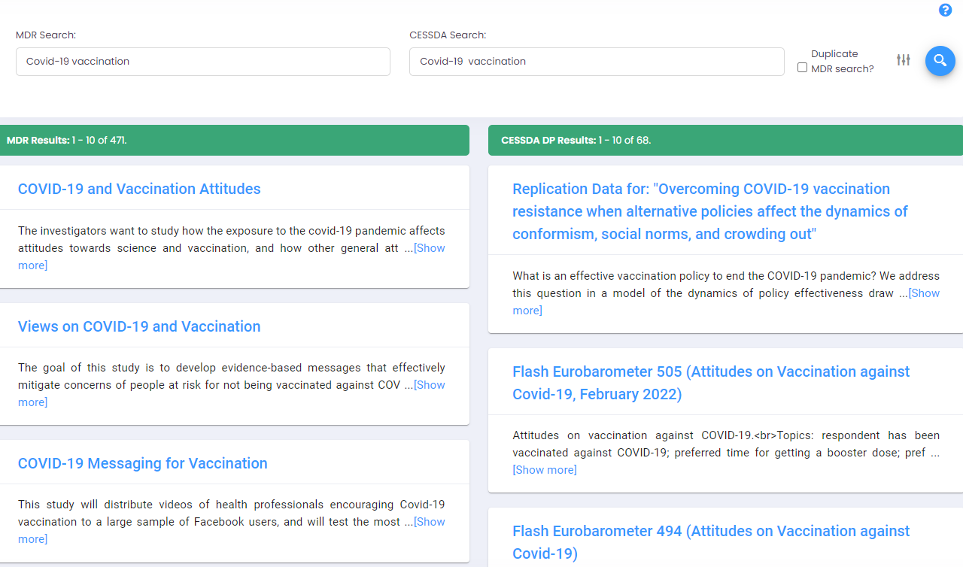
Figure 1: Screen shot from the free text search for “COVID-19” and “vaccination” in the title
(left panel: ECRIN MDR, right panel: CESSDA DC).
If you search in the title for “Covid-19 vaccination rand*” in ECRIN MDR and at the same time for “Covid-19 vaccination attitude” in CESSDA DC, 41 randomised trials about COVID-19 vaccination are retrieved from the ECRIN MDR and 26 studies on attitudes towards COVIS-19 from CESSDA DC.
Further refinement of the search is possible by filtering to study type. Here only rudimentary functionality could be implemented given the limited time and resources. Ideas for improvement are presented in section 4.

- Potential benefit
Two major scenarios are foreseen for the application of the demonstrator:
- Searching complementary study designs in CESSDA DC and ECRIN MDR and perform cross-analysis
- Searching similar study designs in CESSDA DC and ECRIN MDR for systematic reviews and scoping reviews
The ideas behind these applications and the potential benefits are elaborated in appendix 1. In summary, the discovery of studies with complementary designs in CESSDA DC and ECRIN MDR and a cross-analysis could support the generalisability of results from randomised clinical trials to a larger population. In systematic reviews and in scoping reviews usually studies with similar study designs are combined. Especially for COVID-19, there is a variety of interventions from social sciences and clinical research, which are used to combat the disease, or a health issue related to it. This covers social, behavioural, pharmacologic, and non-pharmacological interventions. Therefore, it would make sense to use the application to simultaneously identify similar study types in the CESSDA DC and ECRIN MDR.
- Next steps
Technical work on the demonstrator tool within EOSC-Future TSP was finalised on 30 September 2023. Any further work on the demonstrator needs new funding. Proposals for next steps are:
- Improve the search function of the tool (related to CESSDA)
In the current demonstrator only a basic search capability for resources within CESSDA DC was provided. This search functionality needs to be extended:
- Advanced search strategies with pre-defined search patterns
Here more complex search strategies should be developed to better identify relevant resources in CESSDA with respect to study types. Here recall and precision of study types should be assessed, at least in examples.
- More advanced search strategies definable by users
Here complex search patterns should be constructable by the users themselves (not predefined). This needs additional technical development.
- Turn the demonstrator into a mature tool
To achieve this, major input is needed to improve and extend the functionality of the tool by IT-developers. If there is a need, the tool could be linked with a service. Such a service (as well as the tool) could be registered in the (new) EOSC platform and other catalogues.
- Developing use cases demonstrating the benefits of the tool
In the context of the development of the demonstrator possible scenarios demonstrating the potential benefit of the tool have been explored. This needs to be extended with more relevant examples.
A concrete step to move this forward could be a proposal for an OSCARS project.

- Appendix:
5.1 Potential application areas for CESSDA DC – ECRIN MDR use case
There are two main application types for the CESSDA – ECRIN use case foreseen:
Searching complementary study designs in CESSDA DC and ECRIN MDR and perform cross-analysis
The discovery of studies with complementary designs in CESSDA DC and ECRIN MDR and a cross-analysis could support the generalisability of results from randomised clinical trials to a larger population. Suppose a randomised clinical trial about strategies to prevent COVID-19 infection has revealed a specific vaccination schema as favourable option in a limited and artificial population, it would be of interest to explore what the consequences would be, if the preferred option would be implemented in the full population. Helpful in this context could be population surveys, assessing the attitude towards vaccination strategies in a national population or a representative sample. Adequate analysis and modelling, investigating the transfer and application of data from clinical trials to a larger population, would provide (generalised) evidence to policy makers whether the implementation of the vaccination procedure would lead to the desired results compared to other strategies (e.g., less infections, less complications). In this way, a cross-analysis between clinical trial data and social science survey data could provide useful input into the assessment of potential socioeconomic effects, which may major have implications for health strategies in a country or region.
Currently the datasets needed for this kind of analysis are spread over domains (life sciences – social sciences & humanities) and catalogues/registries/repositories. Information about clinical trials can be found in trial registries (e.g. ,ClinicalTrials.gov), in the ECRIN MDR or elsewhere (e.g., Pubmed). Social science survey data can be found in specific registries and repositories, via the CESSDA DC or in literature databases. Anyway, the different catalogues/repositories must be searched separately. This means that a researcher has to identify and learn about different catalogues and repositories, to explore and apply search engines which differ from each other and to consume output, which is different between the resources. This is an uncomfortable situation, which needs resources and may not guarantee successful search results.
The CESSDA – ECRIN use case is targeting this issue by simultaneously searching two resources, which contain the overwhelming majority of clinical trials (ECRIN MDR) and social science studies (CESSDA DC). An example how this can be applied was given in section 2. For defining the search pattern and presentation of results a specific user portal is provided.
As a starting point, a demonstrator has been developed, where a search can be performed via
- Text (segments) in the title
- Filtering predefined study types (e.g., randomised study, cohort, case-control study)
In the example above the search pattern for the clinical trial could be defined as
- Title: COVID-19 and vaccination ´
- Filtering: “interventional trial” and allocation type = “randomised”
A practical search retrieved 126 trials (29.09.2023) in ECRIN MDR (old version).
In parallel and entered on the same screen, the search pattern for social science studies could be:
- Title: Covid-19 and vaccination and attitude
- No filtering
A practical search retrieved 25 studies (29.09.2023) in CESSDA DC.
A practical application of this approach has been published in Lees, 2021. Here results from clinical trials are applied and generalised to the real-world involving data from social science studies (e.g., taking into consideration existing health systems, cultural norms and values, and the effects of low resource contexts). Another example is dealing with the development of predictive models by combining studies from social sciences and clinical research (e.g., combining survey data on attitudes
towards vaccination with quantitative immunity data from an observational study to develop a more
accurate epidemic spreading model) (de Meijere, 2022).

Searching similar study designs in CESSDA DC and ECRIN MDR for systematic reviews and scoping reviews
In systematic reviews and in scoping reviews usually studies with similar study designs are combined. In systematic reviews often results from randomised trials are analysed together but this approach may also be applied to other study types (e.g., prospective cohorts, case-control studies). Especially for COVID-19, there is a variety of interventions from social sciences and clinical research, which are used to combat the disease, or a health issue related to it. This covers social, behavioural, pharmacologic, and non-pharmacological interventions. Therefore, it would make sense to use the application and search engine described above to simultaneously identify similar study types in the CESSDA DC and ECRIN MDR (Pearson, 2021). The search pattern would include:
- Text (segments) in the title
- Filtering according to a predefined study type (e.g., randomised study, cohort, case-control study)
For the example above the search pattern for the clinical trial could be defined as
- Title: COVID-19 ´
- Filtering: type = “observational” and observational model = “case-control”
A practical search retrieved 322 trials (29.09.2023) in ECRIN MDR (old version).
In parallel and entered on the same screen, the search pattern for social science studies could be
- Title: COVID-19 case-control
- No filtering
A practical search retrieved 18 studies (29.09.2023) in CESSDA DC.
How such an approach could be practically applied is described in Person, 2021.
Other applications
There are many more applications for combination of social science and clinical research data in the COVID-19 literature, which could have been supported by a common search in CESSDA DC and ECRIN MDR.
Examples are:
• Increasing knowledge about diagnosis, treatment, and outcome of COVID-19 by combining social science and clinical trial data (e.g., incorporating social and medical determinants into modelling of COVID-19 and other infectious diseases).
• Increasing knowledge about associations and causal pathways between social capital and income inequality, and COVID-19 and other infectious diseases.
• Capturing psychological and behavioural benefits and pitfalls of intensive diagnostic testing to detect and prevent COVID-19 positive cases.

It must be sorted out how the study type filter in combination with free text search could support these types of analyses. It is expected that more applications will be generated when the tool is available and can be practically applied.

5.2 The search algorithm is the following:
{
"query": {
"simple_query_string": {
"query": request.search_value,
"lenient": true,
"default_operator": "AND",
"flags": "AND|OR|NOT|PHRASE|PRECEDENCE|PREFIX",
"fields": ["titleStudy^4", "abstract^2", "keywords.term^1.5", "*"]
}
},
"aggs": {
"classifications.term4": {
"filter": {
"match_all": {}
},
"aggs": {
"inner": {
"nested": {
"path": "classifications"
},
"aggs": {
"classifications.term": {
"terms": {
"field": "classifications.term",
"size": 2000,
"order": {
"_count": "desc"
}
}
},
"classifications.term_count": {
"cardinality": {
"field": "classifications.term"
}
}
}
}
}
},
"keywords.term5": {
"filter": {
"match_all": {}
},
"aggs": {
"keywordsKeywordField": {
"terms": {
"field": "keywordsKeywordField",
"size": 2000,
"order": {
"_count": "desc"
}
}
},
"keywordsKeywordField_count": {
"cardinality": {
"field": "keywordsKeywordField"
}
}
}
},
"dataCollectionYear6": {
"filter": {
"range": {
"dataCollectionYear": {
"gte": 1900,
"lte": 2023
}
}
},
"aggs": {
"dataCollectionYear": {
"histogram": {
"field": "dataCollectionYear",
"interval": 7,
"min_doc_count": 0,
"extended_bounds": {
"min": 1900,
"max": 2023
}
}
}
}
},
"studyAreaCountries.searchField7": {
"filter": {
"match_all": {}
},
"aggs": {
"inner": {
"nested": {
"path": "studyAreaCountries"
},
"aggs": {
"studyAreaCountries.searchField": {
"terms": {
"field": "studyAreaCountries.searchField",
"size": 500,
"order": {
"_key": "asc"
}
}
},
"studyAreaCountries.searchField_count": {
"cardinality": {
"field": "studyAreaCountries.searchField"
}
}
}
}
}
},
"publisher.publisher8": {
"filter": {
"match_all": {}
},
"aggs": {
"inner": {
"nested": {
"path": "publisherFilter"
},
"aggs": {
"publisherFilter.publisher": {
"terms": {
"field": "publisherFilter.publisher",
"size": 500,
"order": {
"_key": "asc"
}
}
},
"publisherFilter.publisher_count": {
"cardinality": {
"field": "publisherFilter.publisher"
}
}
}
}
}
}
},
"size": 30,
"sort": [{
"_score": "desc"
}],
"highlight": {
"fields": {
"titleStudy": {
"number_of_fragments": 0
},
"abstract": {
"number_of_fragments": 0
}
}
},
"track_total_hits": true,
"min_score": 0.5,
"index": "cessda"
}
where the most important part is this one, where the search query statements exists:
"query": {
"simple_query_string": {
"query": request.search_value,
"lenient": true,
"default_operator": "AND",
"flags": "AND|OR|NOT|PHRASE|PRECEDENCE|PREFIX",
"fields": ["titleStudy^4", "abstract^2", "keywords.term^1.5", "*"]
}
},

- References
Lees S, Sariola S, Schmidt-Sane M, et al.: Key social science priorities for longterm COVID-19 response. BMJ Glob Health. 2021; 6(7): e006741.

de Meijere G, Valdano E, Castellano C, et al.: Attitudes towards booster, testing and isolation, and their impact on COVID-19 response in winter 2022/2023 in France, Belgium, and Italy. medRxiv. 2022.12.30.22283726.

Pearson H: How COVID broke the evidence pipeline. The pandemic stress-tested the way the world produces evidence — and revealed all the flaws. Nature - NEWS FEATURE. 2021.

